|  |  |
| --- | --- |
| **FLOW DIAGRAMS** | |
| **Project Name:** | **FINALyze – Business Financial Analyzer** |
| **Description:** | The web application calculates the Gross margin, Net margin and ROI for products.  This app provides insight into products Finance health and helps in Analysing its investment decision. |
| **Deadline:** | 29th March 2025 |
| **Student Name:** | Mohammed Aiman Khan |

**Context Flow diagrams**

**Data Flow Diagram - 0**

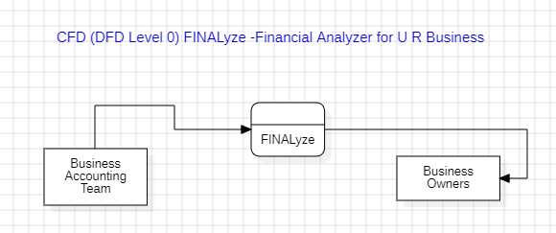

**Data Flow Diagram - 1**

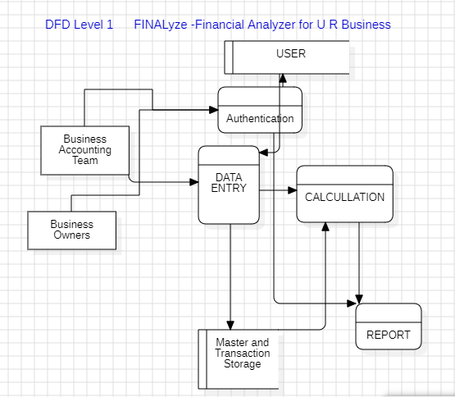

**Data Flow Diagram – 2**

